1)

Hypothesis:

The business structures and population grow have a tendency to grow and then to stagnate at a particular value where the availability of new jobs is less than or equal to the number people available for work. At this point there is no way that the system can have growth. This stagnation could be derived from a variety of factors including limited land to build businesses upon or over population of people.

Tests to run to test hypothesis:

1. Plot the fraction of available jobs to available people alongside the population and Business Structures plots.
2. Add increasing land availability and see how the plot of the defined fraction compares with the increases and stagnations of the population and Business Structures plots.

Outcome:

What we see from the behavior of the graph is that the factor I had defined in my hypothesis does not vary perfectly as an inverse of the growth rates we are seeing but there is still much we can learn about the behavior of the graph from it. The higher the factor is the larger the increase in the slope of the plots of population and business structure. From this it looks like the factor defined in the hypothesis is a factor of the derivative of the two functions; we can use this to describe the behavior of our system.

2)

During the early years there is a large difference between two main factors we described in part one. The Growth factor as part one has defined is large and increasing until a certain point in time when it turns around and drops quickly to zero. The drop to zero can be explained by the population of people expanding faster than the available land to grow new businesses which causes the growth fraction to slow down and eventually turn around. Since the growth fraction is still positive people and business still grow for a time but slower until it reaches zero and everything stagnates.

The limiting quantity which caused the growth in the beginning and which caused the stagnation in the end is the amount of available land. This made the land to people ratio controls the main components of the model and all things are eventually tied to these two points. This makes available land a very important variable to study.

3)

Labor availability starts out low as the urban system begins. As the number of jobs available increases the population for the urban area will also increase. The amount of available labor will continue to increase as the population continues to grow. When the number of jobs slows down the amount of available workers will continue to grow for a short time. But as jobs stay slow the growth in number of available workers will also slow and then the labor and workforce numbers will reach an equilibrium based on the factors that control them.

Labor availability has a delayed response to changes in the jobs available. The delayed response diminishes the number of jobs available quickly which causes the quickly decreasing slope.

4)

The land area limits growth since in order to maintain growth there must be land on which that growth can occur. New buildings can replace old buildings but in order to make a net increase in the number of businesses and business structures the amount of land on which to build will have to be sufficiently large to handle building new structures. The land area will not be completely filled during equilibrium but it will be at a point where the growth of new buildings and the demolition of old buildings has balanced to each an equilibrium with the available job force. In this case we are seeing settled behavior around 90% of land occupied.

5)

Increasing land area a 25 years does not have a significant impact on the shape of the growth but it does give a larger slope and asymptotic behavior still around 90% but this time 90% of 7500 instead of 5000.

Increasing the land area after 75 years had a significant impact on the system. It changed the growth patterns and gave the growth a boost for a short time after it had reached almost equilibrium. It asymptotically reached roughly the same value as when we started with more land; just arrived at the values in a different way.

6)

I do not believe that this assumption invalidates the model. Some cities are unable to physically expand their size due to natural constraints such as surrounding cities. When we look at the case of continuous growth every 20 years if we grow by the same amount our system becomes a linearly growing one always heading towards the asymptote just under maximum capacity. The system does however reach a sort of equilibrium of steady growth. For cities who have enough room around them to grow in this fashion it seems from the model to be a very beneficial way to achieve stable growth. Again limited by the absolute maximum size the city can be geographically. If we were to adjust the system to look at the case of having a fixed amount at a much larger value we see that the behavior is different. Stagnation occurs rapidly as the business and populations boom very quickly to the 90% mark. However in the steady state model when we reached the end of a 200 year simulation we were still at a steady incline and had gotten to a point greater than 90% of filled land closer to 95% and still with a positive slope.

APENDIX:

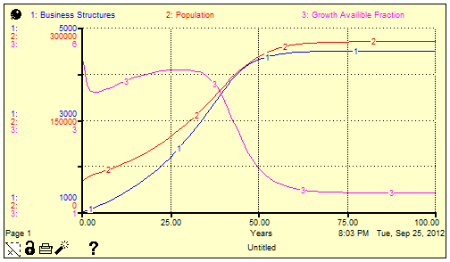

Figure explained: Looking at the plot of the growth factor we can see some of the behavior of the system described here in this plot. When population is growing faster than the business structure we have a negative slope for our third plot. When the Business structure grows faster than population we have our increase in the third plot. It is interesting to see how quickly population catches up with business structure and then continues to grow to a point where they are both at an equilibrium value for the system. When the growth factor plot reaches its maximum around 30 years we can identify this as the point where the population and business structure plots are reaching a critical point and change from a concave up growth patter to a concave down growth pattern. Concave down growth is the slowing of growth and eventual equilibrium pattern.